# Title: On “Команда” page. Clicking on any of multiple “Записатися” buttons opens a pop-up with not-translated into Ukrainian language words.

**Priority:** High

**Severity:** S4 Minor

**Environment:**Google Pixel 7 Pro (3120×1440, Android 11 OS). Tested via Android Studio.

**Steps to reproduce**

1. Open the Main page: [https://zpolis.com.ua](https://zpolis.com.ua/)

2. Click on the “burger-menu” on the left upper-corner of the screen.

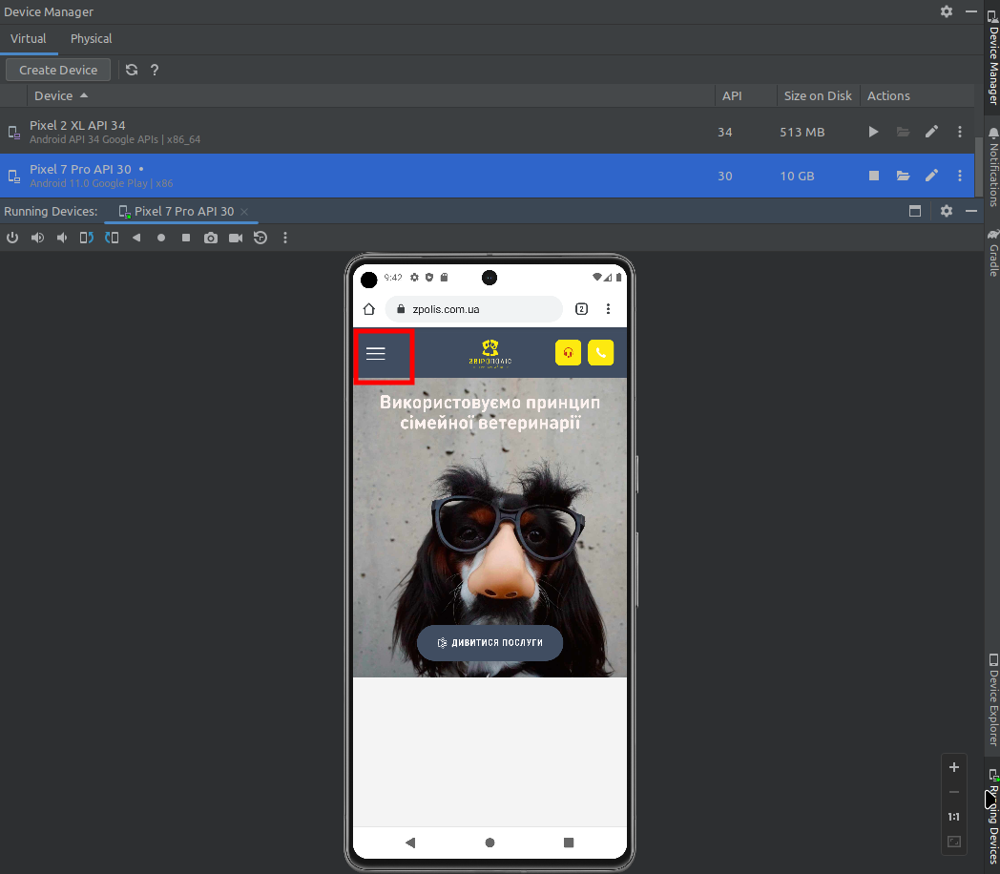

3. On an opened menu click on “Команда” word.

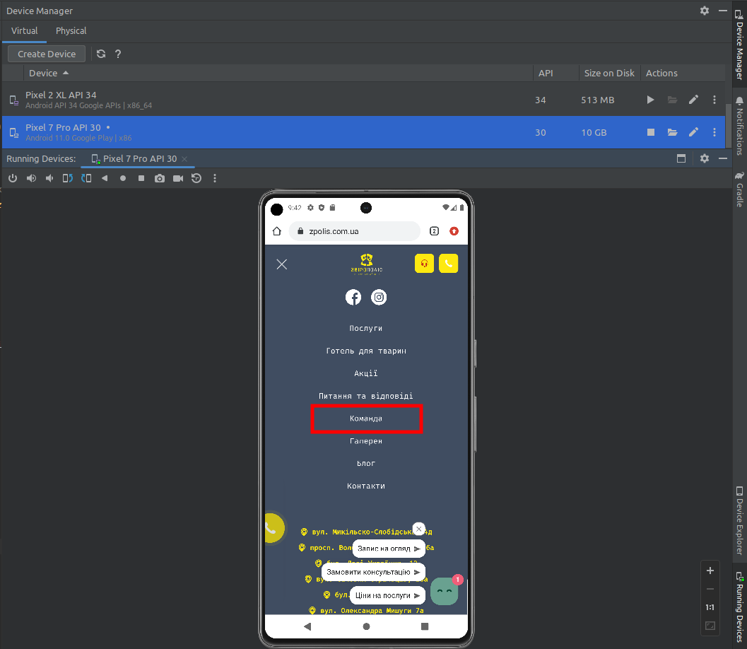

4. Scroll down and click on any of multiple “Записатися” buttons.

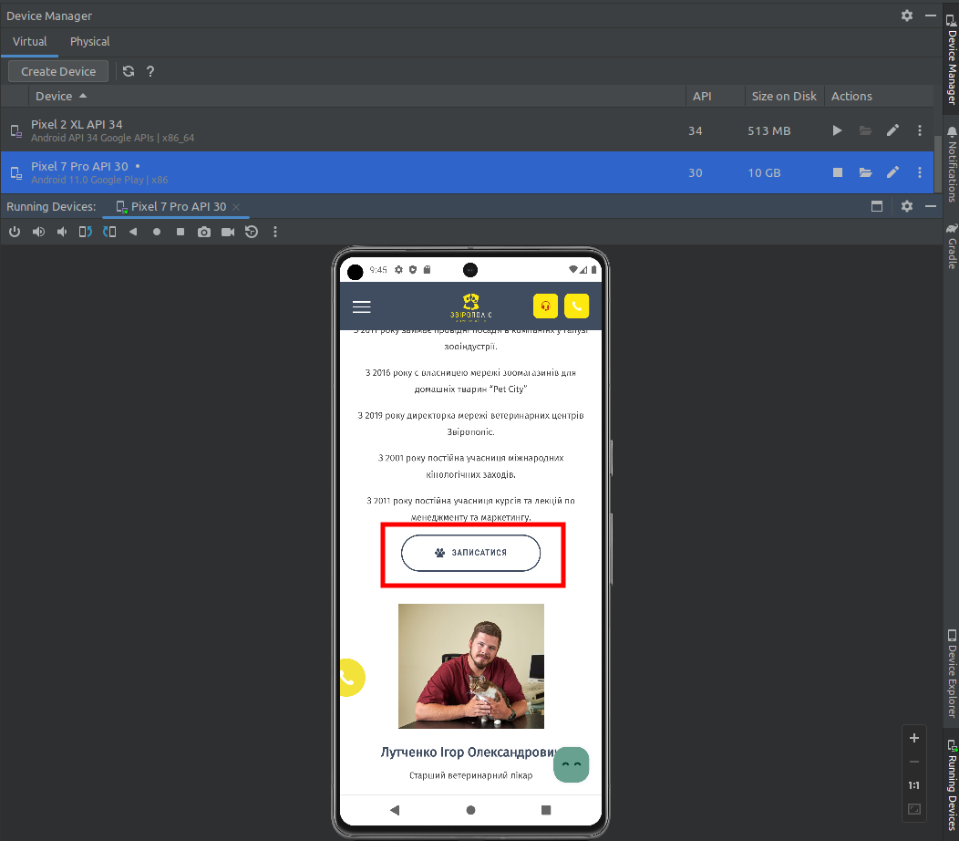

**Actual result**

We see many non-translated words in a pop-up form

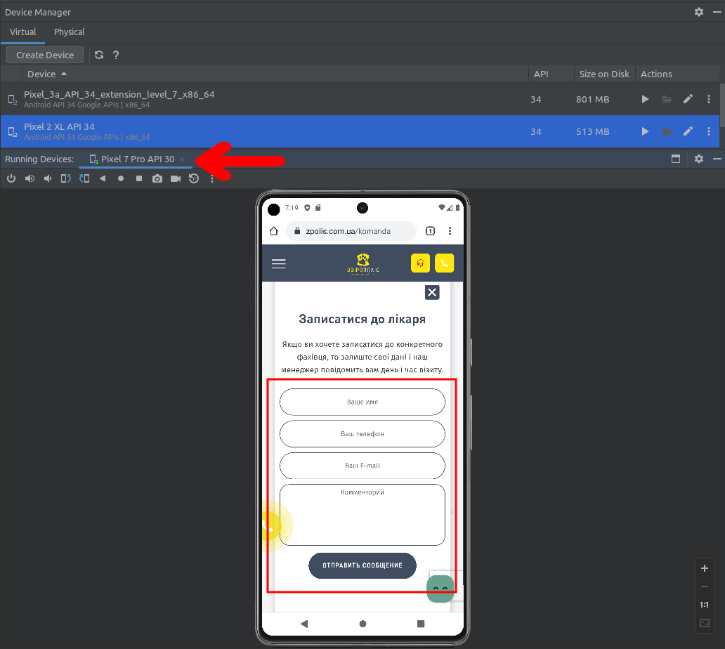

**Expected result**

All words must be in Ukrainian language.

*Screenshot from* ***Jira****:*

